Secondary Roads Department APPLICATION FOR
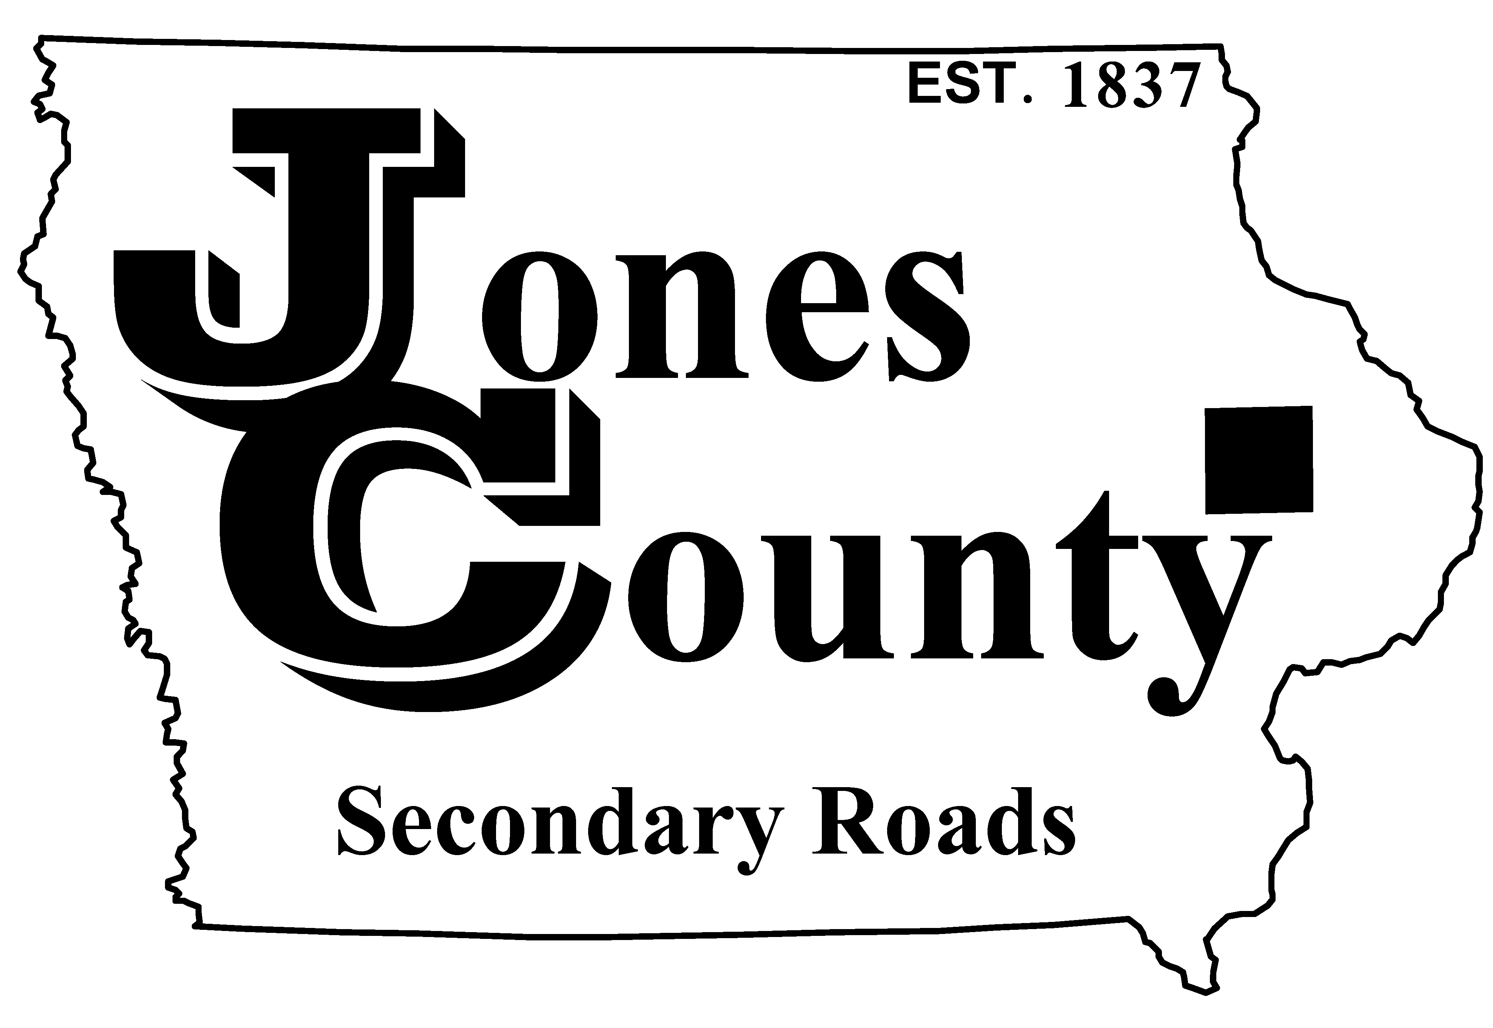
19501 HWY 64, P.O. Box 368 RAW MILK PERMIT
Anamosa, IA 52205
Telephone: (319) 462-3785 Application No.: T-
Email: engineer@co.jones.ia.us Application Fee: $25.00

APPLICANT INFORMATION (PLEASE PRINT CLEARLY OR TYPE)

Vehicle Owner or Lessee: Requested Start Date:

Mailing Address:
(Street Address) (City) (State) (Zip)

Phone Number: Email Address:

POWER UNIT INFORMATION
Plate | State | Vehicle Identification Number (VIN) | Registered Weight | Year | Make

MAXIMUM AXLE WEIGHTS ALLOWED ON THIS PERMIT = 20,000 LBS PER AXLE

Applicant Signature: Approved By:
(Customer or Authorized Agent) Date Jones County Engineer’s Office Date

This permit is for motor trucks only and not for truck-tractor/trailer combinations. It is valid to transport raw milk to or from a milk plant, receiving station, or transfer station. It is NOT valid for interstate travel.

Maximum weight allowed with this permit is 20,000 pounds per axle; not to exceed 80,000 pounds total gross weight. Weight on tires must not exceed manufacturer’s rating.

A copy of this permit must be carried in the vehicle at all times and be available for inspection upon the request of any peace officer. Necessary city and/or Iowa DOT permits must be obtained separately.

