Secondary Roads Department APPLICATION FOR
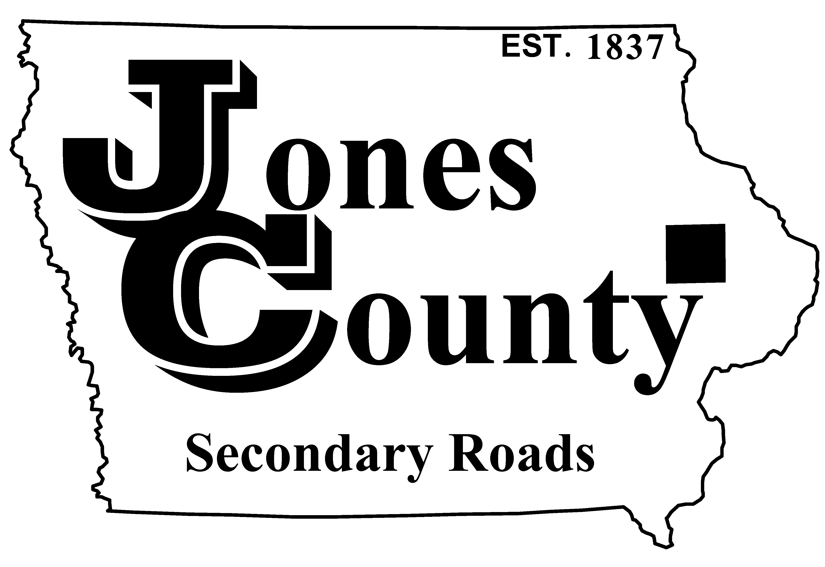
19501 HWY 64, P.O. Box 368 ANNUAL OVERSIZE PERMIT
Anamosa, IA 52205
Telephone: (319) 462-3785 Application No.: T-
Email: engineer@co.jones.ia.us Application Fee: $50.00

APPLICANT INFORMATION (PLEASE PRINT CLEARLY OR TYPE)

Vehicle Owner or Lessee: Requested Start Date:

Mailing Address:
(Street Address) (City) (State) (Zip)

Phone Number: Email Address:

POWER UNIT INFORMATION
Plate | State | Vehicle Identification Number (VIN) | Registered Weight | Year | Make

DIMENSIONS/WEIGHT
Total | Length | Width | Height | Total Weight | Front Projection | Rear Projection
 | (max = 120’-0”) | (max = 16’-0”) | (max = 15’-5”) | (max = 80,000 lbs) | (max = 15’-0”) | (max = 15’-0”)

MAXIMUM AXLE WEIGHTS ALLOWED ON THIS PERMIT = 20,000 LBS PER AXLE

AXLE WEIGHTS/SPACINGS (REQUIRED FOR SME VEHICLES ONLY)
Axle Number | 1 (front) |  | 2 |  | 3 |  | 4 |  | 5 |  | 6 |  | 7 |  | 8
Gross Axle
Weight (lbs)
Axle Spacing

Applicant Signature: Approved By:
(Customer or Authorized Agent) Date Jones County Engineer’s Office Date

Maximum dimensions allowed and travel restrictions on an annual oversize permit are:

- 120’-0” long x 12’-5” wide x 13’-10” high – unlimited distance – no routing required
- 120’-0” long x 14’-6” wide x 15’-5” high – movement restricted to 50 miles radius unless the route continues on at least 4-lane roads or trip routes are obtained from Motor Carrier Services
- 120’-0” long x 16’-0” wide x 15’-5” high – trip routes must be obtained
- 75’-0” long x 12’-5” wide x 14’-6” high – maximum dimensions for hauling hay, straw, stover, and bagged livestock bedding

Carrier will be responsible for obtaining necessary route approval prior to move.

Permits can be issued only for transporting single articles that exceed statutory size limits unless the inclusion of additional articles does not cause the size or weight to further exceed the statutory limits.

